ANNEX 1

Preliminary Agreement

To be returned before 21/07/2020:
Polish Delegation to CISM
Branch of Physical Education and Sports
General Command of the Armed Forces
Ul. Żwirki i Wigury 103
00-912 Warsaw, Poland
Phone: +48 609740624
E-mail : cism-skwierzyna@o2.pl
NOTE that copy of all correspondence should be also sent to: cismpoland@ron.mil.pl

NATION:

TOTAL NUMBER of PARTICIPANTS:
 | Officials | Athletes | Total
Men
Women
Total

Means of transPORT: _________________________________________

DATE:______________ | ___________________________________________________
 | SIGNATURE OF CHIEF OF DELEGATION
 | RANK/NAME:_______________________________________

Your Contact | Rank/Name
Your Contact | Phone
Your Contact | Fax
Your Contact | E-Mail
ANNEX 2a

FINAL ENTRY

To be returned before 24/08/2020:
Polish Delegation to CISM
Branch of Physical Education and Sports
General Command of the Armed Forces
Ul. Żwirki i Wigury 103
00-912 Warsaw, Poland
Phone: +48 609740624
E-mail : cism-skwierzyna@o2.pl
NOTE that copy of all correspondence should be also sent to: cismpoland@ron.mil.pl

NATION

 | PLACE | DATE | FLIGHT Nr  TRAIN Nr  BUS Nr | TIME
ARRIVAL
DEPARTURE

Means of transPORT: _________________________________________

DATE:______________ | __________________________________________________
 | SIGNATURE OF CHIEF OF DELEGATION
 | RANK/NAME:_______________________________________

Your Contact | Rank/Name
Your Contact | Phone
Your Contact | Fax
Your Contact | E-Mail
ANNEX 2b

FINAL ENTRY - COMPOSITION OF THE MISSION
To be returned before 24/08/2020:
Polish Delegation to CISM
Branch of Physical Education and Sports
General Command of the Armed Forces
Ul. Żwirki i Wigury 103
00-912 Warsaw, Poland
Phone: +48 609740624
E-mail : cism-skwierzyna@o2.pl
NOTE that copy of all correspondence should be also sent to: cismpoland@ron.mil.pl

NATION :

# | Function | Rank | Name and Surname | ID/Passport  Number | T-shirt size
1. | Chief of Mission
2. | Coach
3. | Male athlete
4. | Male athlete
5. | Male athlete
6. | Male athlete
7. | Male athlete
8. | Male athlete
9. | Female athlete
10. | Female athlete
11. | Female athlete
12. | Female athlete

In strict compliance with applicable CISM Regulations – Chapter VII, Art. 7.22, I, the undersigned Chief of Delegation, hereby officially confirm that all athletes representing my nation in the CISM event are on active duty in my nation’s Armed Forces. I understand that sanctions may be imposed against my nation, my mission, my team, individual athletes, or myself for violation of this provision (CISM Regulations Chapter I, Art. 1.12).

DATE:______________ | __________________________________________________
 | SIGNATURE OF CHIEF OF DELEGATION
 | RANK/NAME:_______________________________________

ANNEX 3

ROUTE FROM BORDER WITH GERMANY TO FOLWARK AMALIA (60 MINS)

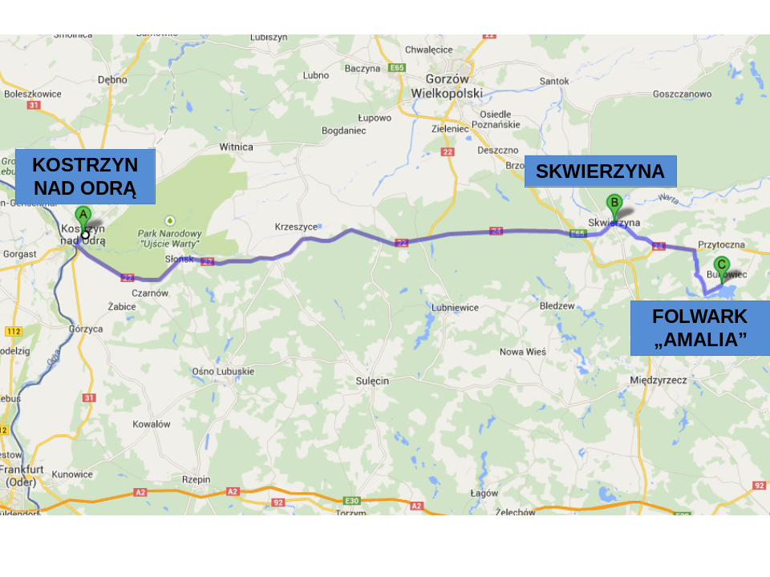

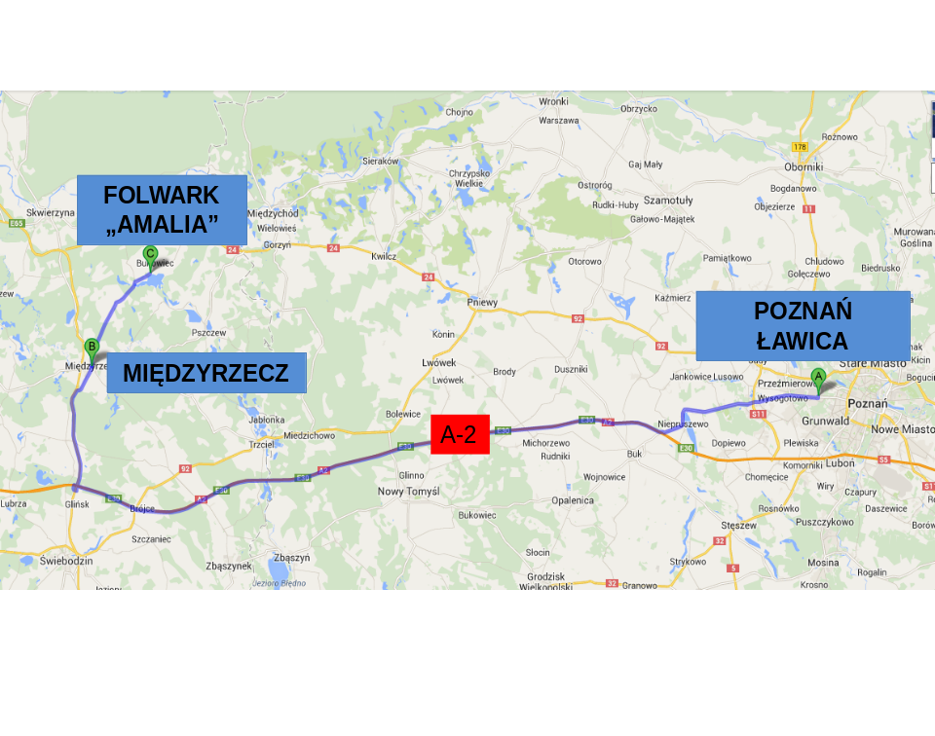ROUTE FROM CIVILIAN AIRPORT POZNAŃ ŁAWICA TO FOLWARK AMALIA (1 HOUR 45 MINS)

ROUTE FROM MILITARY AIRPORT POZNAŃ KRZESINY TO FOLWARK AMALIA (1 HOUR 45 MINS)
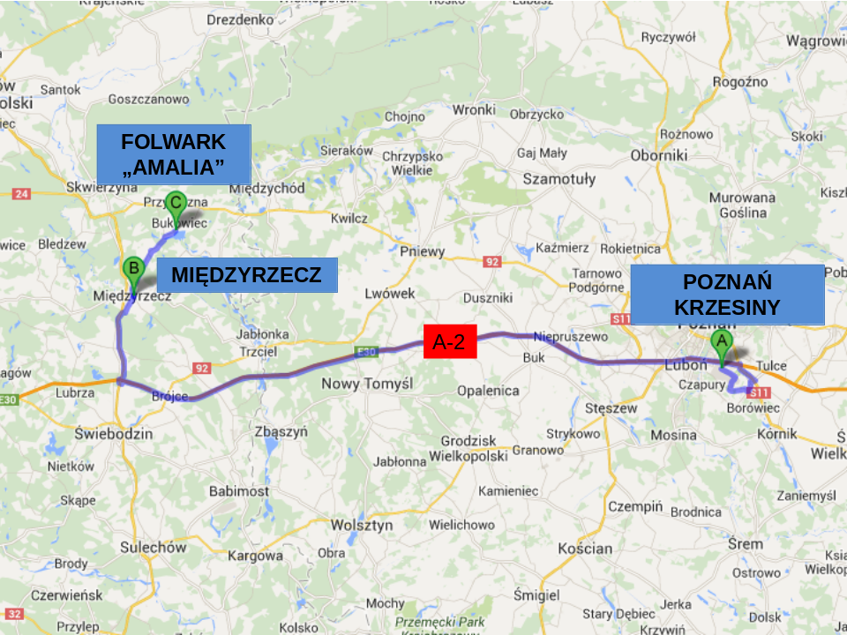

AROUND FOLWARK AMALIA


